CIRCUIT ANALYSIS LAB_4
Name: Muhammad Uzair
Reg No: 2025-CE-112
Date: 28thMarch,2026

Experiment # 1:
Circuit Made In Proteus:
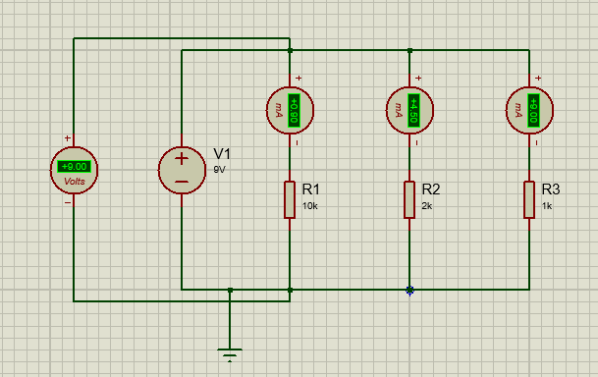
Construction:
- Insert Three Resistors R1, R2 and R3 of 10kΩ, 2 kΩ and 1kΩ resistances respectively.
- Insert DC Voltage Source and Set it to 9V.
- Connect R1, R2 and R3 in parallel with each other.
- Connect terminals of source with both ends of the parallel combination (positive terminal to the top rail, negative terminal to the ground/bottom rail).
- Connect DC Ammeters in series with R1, R2 and R3 for Current measurements across each resistor.
- Connect DC Voltmeter in parallel with R1.
- The Circuit According to the requirements is completed. Run it and Observe.

Experiment # 2:
Circuit Made In Proteus:
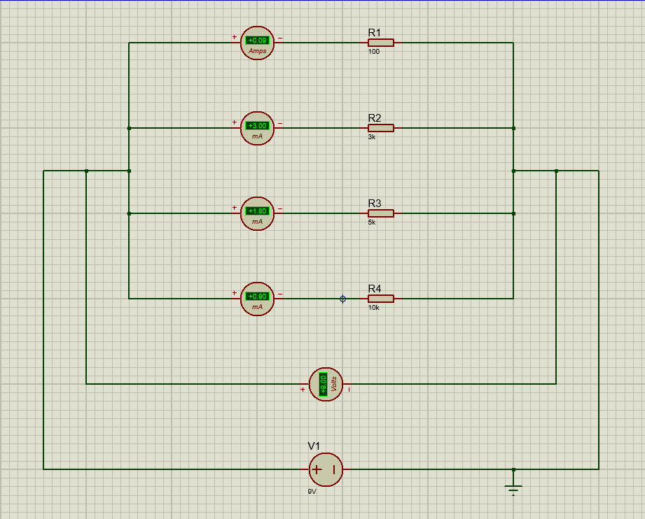
Construction:
- Insert four Resistors R1, R2, R3, and R4 of 100Ω, 3kΩ, 5kΩ and 10 kΩ resistances respectively.
- Insert DC Voltage Source and Set it to 9V.
- Connect R1, R2, R3 and R4 in parallel with each other.
- Connect terminals of source with both ends of the parallel combination (positive terminal to the left rail, negative terminal to the ground/right rail).
- Connect DC Ammeters in series with R1, R2, R3 and R4 for Current measurements across each resistor.
- Connect DC Voltmeter in parallel with parallel combination of resistors to measure voltage across both ends of combination of resistors.
- The Circuit According to the requirements is completed. Run it and Observe.

